UNITED STATES
SECURITIES AND EXCHANGE COMMISSION
Washington, D.C. 20549
Form 6-K
REPORT OF FOREIGN PRIVATE ISSUER PURSUANT TO RULE 13a-16 OR 15d-16 UNDER THE SECURITIES EXCHANGE ACT OF 1934
For the month of August 2026
Commission File Number: 001-41923
EUPRAXIA PHARMACEUTICALS INC.
(Exact name of Registrant as specified in its charter)
N/A
(Translation of Registrant’s name)
2198 Yukon Street
Vancouver, British Columbia, Canada V5Y 3P1
Telephone: (250) 590-3968
(Address and telephone number of registrant’s principal executive office)
Indicate by check mark whether the registrant files or will file annual reports under cover of Form 20-F or Form 40-F.
Form 20-F [ ] Form 40-F [ X ]

DOCUMENTS INCLUDED AS PART OF THIS REPORT
Exhibit
99.1 |  | Press Release dated August 13, 2026

SIGNATURES
Pursuant to the requirements of the Securities Exchange Act of 1934, the registrant has duly caused this report to be signed on its behalf by the undersigned, thereunto duly authorized.
 | EUPRAXIA PHARMACEUTICALS INC.
Date: August 13, 2026 | By: | /s/ Alex Rothwell
 |  | Name: Alex Rothwell
 |  | Title: Chief Financial Officer
EXHIBIT 99.1
Eupraxia Pharmaceuticals Reports Symptom Response Data from its Ongoing Phase 1b/2a RESOLVE Trial, Including New Data on Odynophagia (Painful Swallowing) in Eosinophilic Esophagitis Patients
- The number of patients experiencing moderate to severe odynophagia (pain swallowing) in the cohorts analyzed (Cohorts 7-9) was reduced from 62% at baseline to 25% from 24 through to 52 weeks post treatment
- In the same analysis, 23% of patients reported severe odynophagia at baseline; and no patients reported severe odynophagia at the 24 and 52 weeks timepoints
- The number of patients experiencing moderate to severe dysphagia (difficulty swallowing) in Cohorts 7-9 was reduced from 77% at baseline to 25% at 24 and 52 weeks post treatment
- At baseline 31% of patients in Cohorts 7-9 had severe dysphagia; no patients had severe dysphagia at 24 and 52 weeks post treatment
- EP-104GI continues to be well tolerated by patients receiving the drug. There have been over 130 patients treated in RESOLVE with EP-104GI or placebo (more than 2,000 individual injection sites) with no reported treatment-emergent or procedure related Serious Adverse Events (“SAEs”)
VANCOUVER, British Columbia, Aug. 13, 2026 (GLOBE NEWSWIRE) -- Eupraxia Pharmaceuticals Inc. (“Eupraxia” or the “Company”) (NASDAQ:EPRX) (TSX:EPRX), a clinical-stage biotechnology company leveraging its proprietary Diffusphere technology designed to optimize local, controlled drug delivery for applications with significant unmet need, today announced positive results from a new analysis of the RESOLVE study examining the effect of EP-104GI on symptom severity, including for the first time an analysis of the effect of EP-104GI on odynophagia (pain when swallowing). This is important because odynophagia scoring is a component of Dysphagia Symptom Questionnaire (DSQ), a commonly used patient reported outcome used in pivotal clinical trials in EoE patients.
“The results from this analysis of Phase 1b/2a data, which looks at the proportion of patients that exhibit different levels of symptom severity following treatment with EP-104GI, support our previously released results and implies that EP-104GI is having a meaningful effect for EoE patients,” said Dr. Jeymi Tambiah, Chief Medical Officer of Eupraxia. “In our analysis, we looked at symptom severity in measures of dysphagia and odynophagia at baseline through week 52 of the study. In these measures, we saw meaningful shifts in the proportions of patients towards milder scores for their symptoms. Importantly, this is the first time that we have presented data on odynophagia, which is pain experienced when swallowing food. Odynophagia is experienced by many EoE patients and can have a dramatic effect on a patient’s quality of life1. In the study there were noted decreases in the number of patients that experienced odynophagia compared to baseline, starting as early as 2 weeks and lasting out to 52 weeks.”
“The results demonstrating that patients treated with EP-104GI experienced an improvement across two distinct measures of symptoms are highly encouraging,” continued Dr. Tambiah. “We are also reassured by the low rates and similar profiles of adverse events across both phases of the trial. In the two portions of the Phase 1b/2 RESOLVE trial, there have been over 130 patients treated with EP-104GI or placebo, which equates to more than 2,000 individual injection sites. We have observed no treatment-emergent or procedure related Serious Adverse Events (SAEs) and have no concerns regarding mean glucose or cortisol levels.”
Dr. James Helliwell, Chief Executive Officer of Eupraxia, said, “What is especially encouraging in this finding is that EP-104GI is continuing to demonstrate consistent biological responses. Patients are seeing improvement in their ability to swallow without food becoming stuck, in the pain they experience with swallowing, in endoscopic findings of disease and histologic severity of disease. These improvements seem to be showing durability to 52 weeks. We continue to anticipate our key Phase 2b placebo-controlled interim readout in Q4 of this year.”
Key results from the analysis of odynophagia following dosing with EP-104GI
Patients in the RESOLVE trial were asked to grade the degree of odynophagia (pain whilst swallowing) on an 11-point scale (0 = no pain, 10 = most severe pain) over the seven previous days. Measurements were recorded at baseline and at weeks 2, 4, 8, 12, 24, 36 and 52 following dosing with EP-104GI. Symptom severity was graded as most severe (score of 10), severe (scores of 7-9), moderate (scores of 4-6), mild (scores of 1-3) or none (score of 0). An analysis of the distribution of severity of symptom score was performed for the patients that received 20 injections of EP-104GI (Cohorts 7 to 9, receiving a total dose ranging from 80 mg to 160 mg in 20 injections). The results are presented in the figure below.
Key highlights from the odynophagia analysis:
- At baseline 62% of the EoE patients reported either moderate or severe odynophagia (n=13)
- At 2, 4, 8 and 12 weeks post treatment, 31% of patients reported moderate or severe odynophagia (n=13)
- At 24, 36 and 52 weeks, 25% of patients reported moderate or severe odynophagia (n = 12,12 and 8 respectively)
- At baseline, 15% of patients recorded no odynophagia, at 52 weeks, 50% of patients recorded no odynophagia
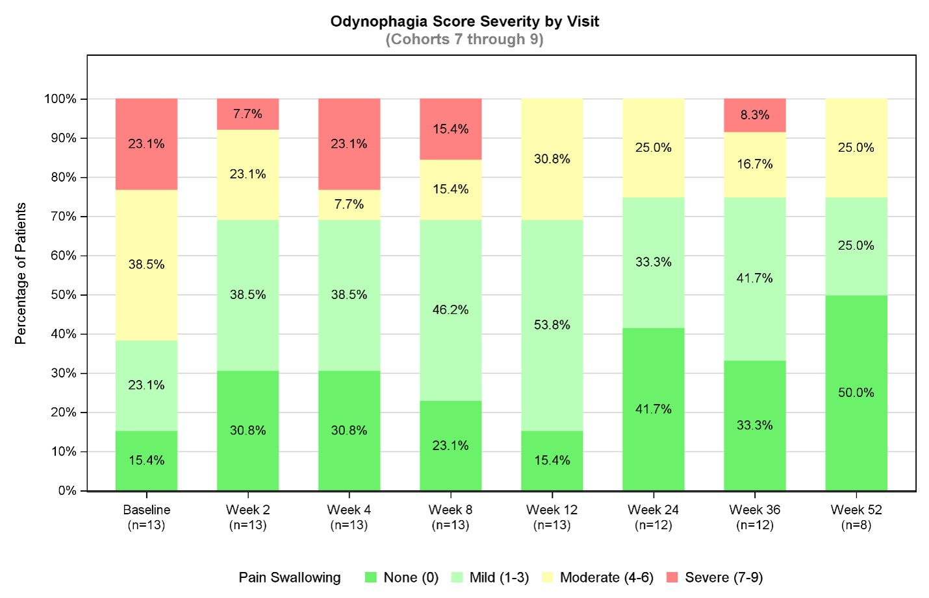
Graph shows patient odynophagia category groups changes from baseline to week 52 in the Phase 1b/2a portion of the RESOLVE trial
Cohorts 7 to 9 received a total dose ranging from 80 mg to 160 mg in 20 injections
N.B. figure shows distribution of patients by categories per visit, not individual changes
Key results from the analysis of dysphagia following dosing with EP-104GI
Patients in the RESOLVE trial were asked to grade the degree of dysphagia (difficulty swallowing) on an 11-point scale (0 = no troubles to swallow, 10 = most severe troubles to swallow) over the seven previous days. Measurements were recorded at baseline and at weeks 2, 4, 8, 12, 24, 36 and 52 following dosing with EP-104GI. Symptom severity was graded as most severe (score of 10), severe (scores of 7-9), moderate (scores of 4-6), mild (scores of 1-3) or none (score of 0). An analysis of the distribution of severity of symptom score was performed for the patients that received 20 injections of EP-104GI (Cohorts 7-9, receiving a total dose ranging from 80 mg to 160 mg). The results are presented in the figure below.
Key highlights from the dysphagia analysis:
- At baseline 77% of the EoE patients reported moderate or severe dysphagia (n=13)
- At 12 weeks post treatment, 54% of patients reported moderate or severe dysphagia (n=13)
- At 24 and 52 weeks, only 25% of patients reported moderate or severe dysphagia (n = 12 and 8 respectively)
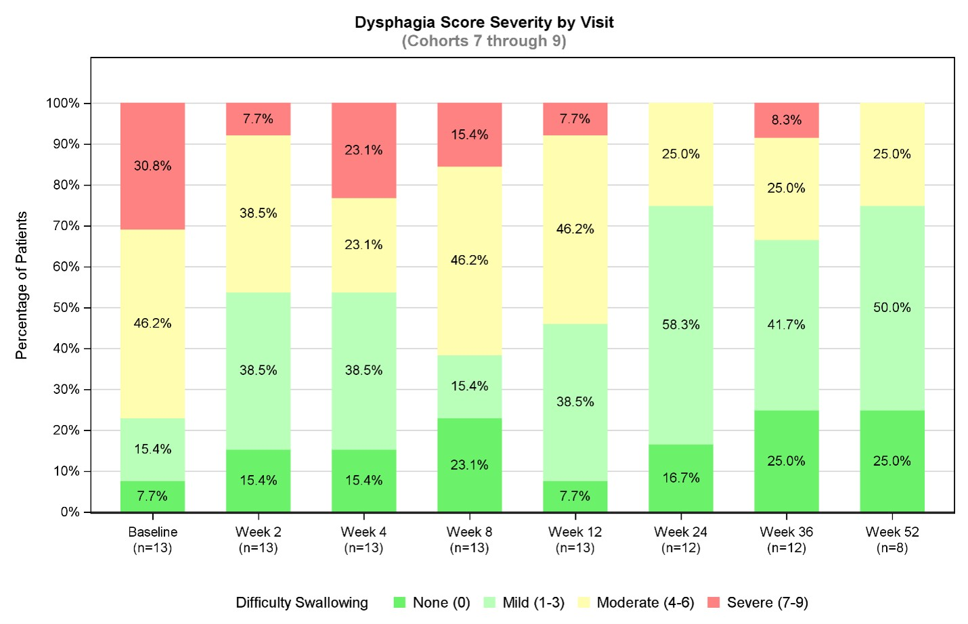
Graph shows patient dysphagia category groups changes from baseline to week 52 in the Phase 1b/2a portion of the RESOLVE trial
Cohorts 7 to 9 received a total dose ranging from 80 mg to 160 mg in 20 injections
N.B. figure shows distribution of patients by categories per visit, not individual changes
A summary of the above odynophagia results are included in the Eupraxia Corporate Presentation available on the Eupraxia Pharmaceuticals website and can be found here.
About the RESOLVE Trial
The Phase 1b/2a part of the RESOLVE trial is a multicenter, open-label, dose-escalation study evaluating the safety, tolerability, pharmacokinetics, and efficacy of EP-104GI in adults with a history of confirmed active EoE. The treatment is administered as a single dose via 4 to 20 esophageal wall injections, with dose escalations modifying either the dose per site and/or the number of sites. Patients were followed for up to 24 weeks in Cohorts 1-4 (4x1mg, 8x1mg, 8x2.5mg and 12x2.5mg) or 52 weeks in Cohorts 5-9 (12x4mg, 16x4mg, 20x4mg, 20x6mg and 20x8mg). Eupraxia plans to disclose additional data from the open-label Phase 1b/2a part of the RESOLVE trial in the coming months.
The Phase 2b part of the RESOLVE trial, a randomized placebo-controlled study of EP-104GI, is currently recruiting both the 120mg (20x6mg) and 160mg (20x8mg) doses. The interim data from the Phase 2b part of the RESOLVE trial is expected in Q4 2026.
Notes
1 Karpf et al. (2024) Digestive Diseases and Sciences. 69(10):3853-3862
About Eosinophilic Esophagitis (EoE)
EoE is an inflammatory-mediated disease in which white blood cells migrate into and become trapped in the esophagus, creating pain and difficulty with swallowing food. According to market research from Clearview Healthcare Partners, EoE affects more than 450,000 people in the United States and has been identified by the American Gastroenterological Association as rapidly increasing in both incidence and prevalence. Impacts from both symptoms and interventions frequently lead to mental health issues, compounding the disease burden of EoE for both the healthcare system and the individual.
About Eupraxia Pharmaceuticals Inc.
Eupraxia is a clinical-stage biotechnology company focused on the development of locally delivered, extended-release products that have the potential to address therapeutic areas with high unmet medical need. Diffusphere, a proprietary, polymer-based micro-sphere technology, is designed to facilitate targeted drug delivery of both existing and novel drugs. The technology is designed to support extended duration of effect and delivery of drugs in a hyper-localized fashion, targeting only the tissues that physicians are wanting to treat. We believe the potential for fewer adverse events may be achieved through the precision targeting and the stable and flat delivery of the active ingredient when using the Diffusphere technology, versus the peaks and troughs seen with more traditional drug delivery methods. The precision of Eupraxia's Diffusphere technology platform has the potential to augment and transform existing FDA-approved drugs to improve their safety, tolerability, efficacy and duration of effect. The potential uses in therapeutic areas may go beyond pain and inflammatory gastrointestinal disease, where Eupraxia currently is developing advanced treatments, to also be applicable in oncology, infectious disease and other critical disease areas.
Eupraxia's EP-104GI is currently in a Phase 1b/2 trial, the RESOLVE trial, for the treatment of EoE. EP-104GI is administered as an injection into the esophageal wall, providing local delivery of drug. This is a unique treatment approach for EoE. In addition, Eupraxia is developing a pipeline of later and earlier-stage long-acting formulations. For further details about Eupraxia, please visit the Company's website at: www.eupraxiapharma.com.
Notice Regarding Forward-looking Statements and Information
This news release includes forward-looking statements and forward-looking information within the meaning of applicable securities laws. Often, but not always, forward-looking information can be identified by the use of words such as "plans", "is expected", "expects", "suggests", “indicates”, "scheduled", "intends", "contemplates", "anticipates", "believes", "proposes", "potential" or variations (including negative and grammatical variations) of such words and phrases, or statements that certain actions, events or results "may", "could", "would", "might" or "will" be taken, occur or be achieved. Forward-looking statements in this news release include statements regarding the interpretation of data from the RESOLVE trial, including symptom response, tissue health and the durability of treatment effects; the Company’s expected timing of reporting additional data from the RESOLVE trial, including the Phase 2b portion thereof; the Company's product candidates, including their expected benefits with respect to safety, tolerability, efficacy and duration of effect and their potential use in therapeutic areas beyond pain and inflammatory gastrointestinal disease; the expectations regarding the advancement of the Company’s product candidates through clinical development; the results of clinical trials of the Company's product candidates; the potential for the Company’s technology to impact the drug delivery process; the potential market opportunity for the Company’s product candidates; and potential pipeline indications. Such statements and information are based on the current expectations of Eupraxia's management, and are based on assumptions, including but not limited to: future research and development plans for the Company proceeding substantially as currently envisioned; industry growth trends, including with respect to projected and actual industry sales; the Company's ability to obtain positive results from the Company's research and development activities, including clinical trials; and the Company's ability to protect patents and proprietary rights. Although Eupraxia's management believes that the assumptions underlying these statements and information are reasonable, they may prove to be incorrect. The forward-looking events and circumstances discussed in this news release may not occur by certain dates or at all and could differ materially as a result of known and unknown risk factors and uncertainties affecting Eupraxia, including, but not limited to: risks and uncertainties related to the Company's limited operating history; the Company's novel technology with uncertain market acceptance; if the Company breaches any of the agreements under which it licenses rights to its product candidates or technology from third parties, the possibility that the Company could lose license rights that are important to its business; the possibility that the Company's current license agreement may not provide an adequate remedy for its breach by the licensor; the possibility that the Company's technology may not be successful for its intended use; the fact that the Company's future technology will require regulatory approval, which is costly and the Company may not be able to obtain it; the possibility that the Company may fail to obtain regulatory approvals or only obtain approvals for limited uses or indications; the possibility that the Company's clinical trials may fail to demonstrate adequately the safety and efficacy of its product candidates at any stage of clinical development; the possibility that the Company may be required to suspend or discontinue clinical trials due to side effects or other safety risks; the fact that the Company completely relies on third parties to provide supplies and inputs required for its product candidates and services; the potential impact of tariffs on the cost of the Company’s active pharmaceutical ingredients and clinical supplies of EP-104GI; the fact that the Company relies on external contract research organizations to provide clinical and non-clinical research services; the possibility that the Company may not be able to successfully execute its business strategy; the fact that the Company will require additional financing, which may not be available; the fact that any therapeutics the Company develops will be subject to extensive, lengthy and uncertain regulatory requirements, which could adversely affect the Company's ability to obtain regulatory approval in a timely manner, or at all; the impact of health pandemics or epidemics on the Company's operations; the Company's restatement of its consolidated financial statements, which may lead to additional risks and uncertainties, including loss of investor confidence and negative impacts on the Company's common share price; and other risks and uncertainties described in more detail in Eupraxia's public filings on SEDAR+ (sedarplus.ca) and EDGAR (sec.gov). Although Eupraxia has attempted to identify important factors that could cause actual actions, events or results to differ materially from those described in forward-looking statements and information, there may be other factors that cause actions, events or results to differ from those anticipated, estimated or intended. No forward-looking statement or information can be guaranteed. Except as required by applicable securities laws, forward-looking statements and information speak only as of the date on which they are made and Eupraxia undertakes no obligation to publicly update or revise any forward-looking statement or information, whether as a result of new information, future events or otherwise.
For investor and media inquiries, please contact:
James Meikle, Eupraxia Pharmaceuticals Inc.
236-330-7084
jmeikle@eupraxiapharma.com
or
Kevin Gardner, on behalf of:
Eupraxia Pharmaceuticals Inc.
617-283-2856
kgardner@lifesciadvisors.com
SOURCE Eupraxia Pharmaceuticals Inc.
Photos accompanying this announcement are available at:
https://www.globenewswire.com/NewsRoom/AttachmentNg/96e845d8-5ddf-415d-8f38-8eb6bd863f6d
https://www.globenewswire.com/NewsRoom/AttachmentNg/1aea593c-8f82-4a0b-be6d-9703aecb149a

